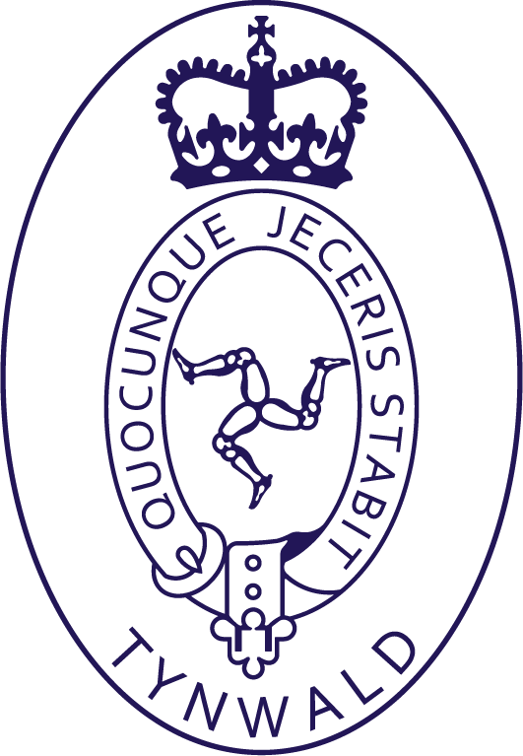 | Statement of Commission Sales Invoices Outstanding
Year Ending 31st March 2019
Date: December 31, 2020

 |  | From | Office of the Clerk of Tynwald  Legislative Buildings  Finch Road  Douglas, Isle of Man  IM1 3PW | To | ELEMENTIsle  Grenaby Studios  Ballabeg

Supplier Details |  |  |  | Sales Period | Government Order
Element.Isle |  |  |  | Various | [PO Ref]

Qty | Description | Sale Price £ | Period
1 | Clam earrings | 12.00 | May 2018
1 | Scallop earrings | 12.00 | September 2018
1 | Entwined Silver Twig Necklace | 45.00 | Winter 2018/19
1 | Perwick Freeform Silver Necklace | 70.00 | Winter 2020
1 | Twig Earrings | 34.00 | Winter 2020
We are still awaiting an invoice for the above items.
For all items sold in the Tynwald Gift Shop we charge a 20% commission (sale price less 20%)
Please include Bank Account details for payment:
Name on the account:
Sort Code:
Account Number:

Legislative Buildings  Douglas  Isle of Man  IM1 3PW  Telephone: 01624 685520 | Tynwald Library  Shamyr-Lioar Tinvaal | Oikyn Slattyssagh  Doolish  Ellan Vannin  IM1 3PW  Chellvane: 01624 685520
28th May 2021
Dear Claire
Please find enclosed another notification of sales summary for two commission sales through the Tynwald Gift Shop.
Sales Period | Qty | Description | Sale Price per item
Winter 2020 | 1 | Perwick Freeform Silver Necklace | 70.00
Winter 2020 | 1 | Twig Earrings | 34.00
I have also included a statement of other invoices we are awaiting. Please can you arrange an invoice to be sent to the Library so we can pay you for these items.
Sales Period | Qty | Description | Sale Price per item
May 2018 | 1 | Clam earrings | 12.00
September 2018 | 1 | Scallop earrings | 12.00
Winter 2018/19 | 1 | Entwined Silver Twig Necklace | 45.00
We cannot pay without an invoice.
This is a summary up to and including 28th May 2021.
With Compliments library@tynwald.org.im Lesh Yeearreeyn Share

